Step 1 :
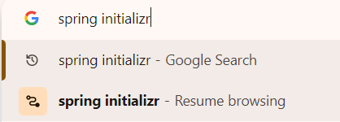

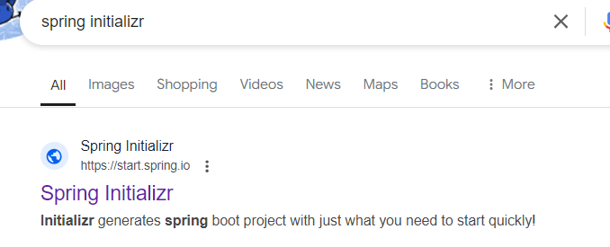

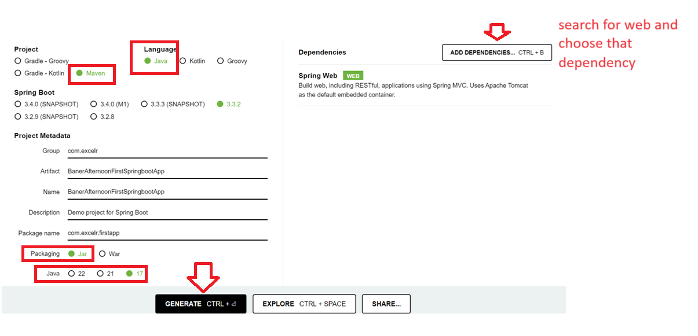
Once you click on GENERATE , it will download a jar file into the downloads folder
Step 2 :
Extract the downloaded jar file (at any location in a clean folder)

Step 3:
In the extracted folder application open pom.xml and modify the following settings
- Jdk version
Line 30 <java.version>1.8</java.version>

- Springboot version
line 8 <version>2.6.0</version>

save the pom.xml and close the file

Step 4
Now Copy the extracted folder and paste in your eclipse workspace

Step 5 :
Open the project in eclipse
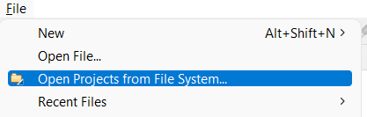

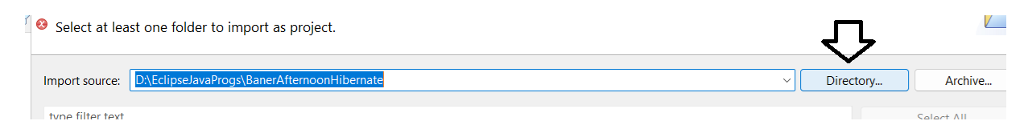
Browse for the pasted folder on the hard disk and add it
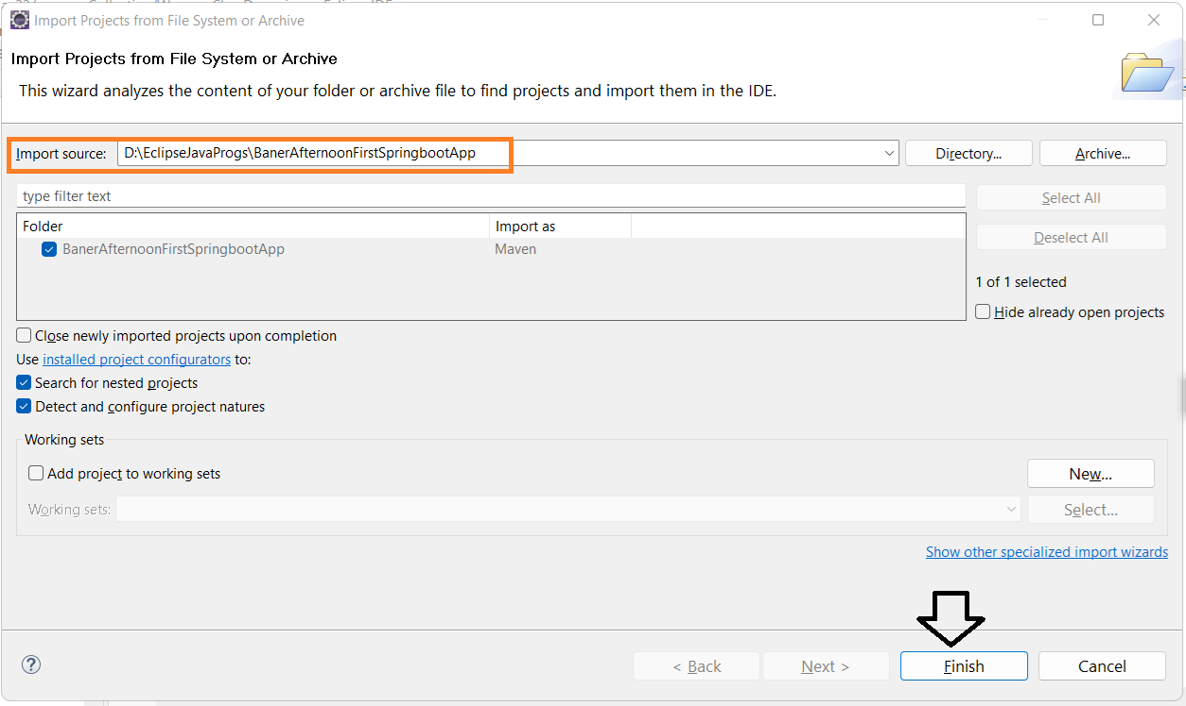
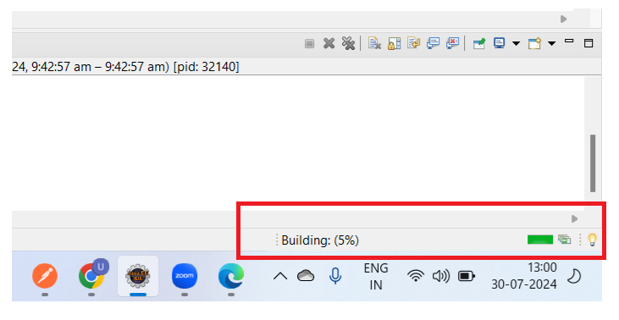
Note : After finishing pls make sure that the bottom right progress bar completes, don’t do anything before the completion of the progressbar(for the first app it might take some time)
Note : Pls have a stable internet connection at this time.
The application will reflect in eclipse now.
